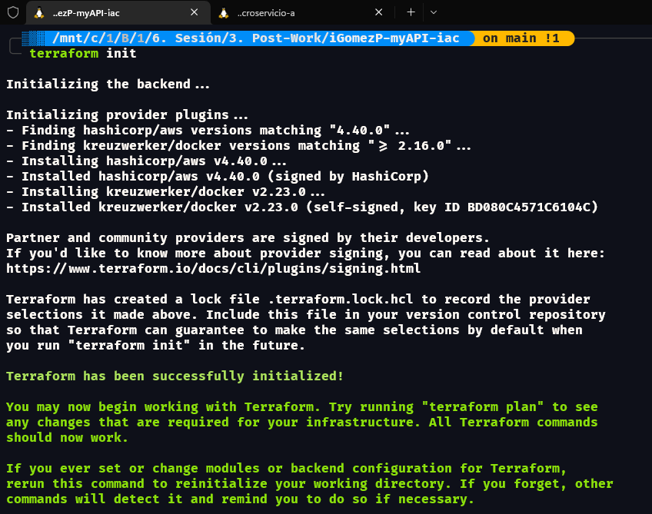

╭─░▒▓ /mnt/c/1/B/1/6. Sesión/3. Post-Work/iGomezP-myAPI-iac  on main !1 ?2 ──────────────────────────────────────────────────────────────────────────────────── ✔  at 04:57:56 PM ▓▒░─╮

╰─ terraform plan -out=tfplan ─╯

Terraform used the selected providers to generate the following execution plan. Resource actions are indicated with the following symbols:

+ create

Terraform will perform the following actions:

# aws_instance.ec2_instance will be created

+ resource "aws_instance" "ec2_instance" {

+ ami = "ami-03f6d497fceb40069"

+ arn = (known after apply)

+ associate_public_ip_address = (known after apply)

+ availability_zone = (known after apply)

+ cpu_core_count = (known after apply)

+ cpu_threads_per_core = (known after apply)

+ disable_api_stop = (known after apply)

+ disable_api_termination = (known after apply)

+ ebs_optimized = (known after apply)

+ get_password_data = false

+ host_id = (known after apply)

+ host_resource_group_arn = (known after apply)

+ id = (known after apply)

+ instance_initiated_shutdown_behavior = (known after apply)

+ instance_state = (known after apply)

+ instance_type = "t2.micro"

+ ipv6_address_count = (known after apply)

+ ipv6_addresses = (known after apply)

+ key_name = (known after apply)

+ monitoring = (known after apply)

+ outpost_arn = (known after apply)

+ password_data = (known after apply)

+ placement_group = (known after apply)

+ placement_partition_number = (known after apply)

+ primary_network_interface_id = (known after apply)

+ private_dns = (known after apply)

+ private_ip = (known after apply)

+ public_dns = (known after apply)

+ public_ip = (known after apply)

+ secondary_private_ips = (known after apply)

+ security_groups = (known after apply)

+ source_dest_check = true

+ subnet_id = (known after apply)

+ tags = {

+ "Environment" = "Develop"

+ "Name" = "dev-server-1"

+ "Owner" = "iGomezP"

}

+ tags_all = {

+ "Environment" = "Develop"

+ "Name" = "dev-server-1"

+ "Owner" = "iGomezP"

}

+ tenancy = (known after apply)

+ user_data = (known after apply)

+ user_data_base64 = (known after apply)

+ user_data_replace_on_change = false

+ vpc_security_group_ids = (known after apply)

+ capacity_reservation_specification {

+ capacity_reservation_preference = (known after apply)

+ capacity_reservation_target {

+ capacity_reservation_id = (known after apply)

+ capacity_reservation_resource_group_arn = (known after apply)

}

}

+ ebs_block_device {

+ delete_on_termination = (known after apply)

+ device_name = (known after apply)

+ encrypted = (known after apply)

+ iops = (known after apply)

+ kms_key_id = (known after apply)

+ snapshot_id = (known after apply)

+ tags = (known after apply)

+ throughput = (known after apply)

+ volume_id = (known after apply)

+ volume_size = (known after apply)

+ volume_type = (known after apply)

}

+ enclave_options {

+ enabled = (known after apply)

}

+ ephemeral_block_device {

+ device_name = (known after apply)

+ no_device = (known after apply)

+ virtual_name = (known after apply)

}

+ maintenance_options {

+ auto_recovery = (known after apply)

}

+ metadata_options {

+ http_endpoint = (known after apply)

+ http_put_response_hop_limit = (known after apply)

+ http_tokens = (known after apply)

+ instance_metadata_tags = (known after apply)

}

+ network_interface {

+ delete_on_termination = (known after apply)

+ device_index = (known after apply)

+ network_card_index = (known after apply)

+ network_interface_id = (known after apply)

}

+ private_dns_name_options {

+ enable_resource_name_dns_a_record = (known after apply)

+ enable_resource_name_dns_aaaa_record = (known after apply)

+ hostname_type = (known after apply)

}

+ root_block_device {

+ delete_on_termination = (known after apply)

+ device_name = (known after apply)

+ encrypted = (known after apply)

+ iops = (known after apply)

+ kms_key_id = (known after apply)

+ tags = (known after apply)

+ throughput = (known after apply)

+ volume_id = (known after apply)

+ volume_size = (known after apply)

+ volume_type = (known after apply)

}

}

# aws_subnet.dev-subnet-public-1 will be created

+ resource "aws_subnet" "dev-subnet-public-1" {

+ arn = (known after apply)

+ assign_ipv6_address_on_creation = false

+ availability_zone = "us-west-1a"

+ availability_zone_id = (known after apply)

+ cidr_block = "10.0.1.0/24"

+ enable_dns64 = false

+ enable_resource_name_dns_a_record_on_launch = false

+ enable_resource_name_dns_aaaa_record_on_launch = false

+ id = (known after apply)

+ ipv6_cidr_block_association_id = (known after apply)

+ ipv6_native = false

+ map_public_ip_on_launch = true

+ owner_id = (known after apply)

+ private_dns_hostname_type_on_launch = (known after apply)

+ tags = {

+ "Name" = "dev-subnet-public-1"

}

+ tags_all = {

+ "Name" = "dev-subnet-public-1"

}

+ vpc_id = (known after apply)

}

# aws_vpc.dev-vpc will be created

+ resource "aws_vpc" "dev-vpc" {

+ arn = (known after apply)

+ cidr_block = "10.0.0.0/16"

+ default_network_acl_id = (known after apply)

+ default_route_table_id = (known after apply)

+ default_security_group_id = (known after apply)

+ dhcp_options_id = (known after apply)

+ enable_classiclink = (known after apply)

+ enable_classiclink_dns_support = (known after apply)

+ enable_dns_hostnames = true

+ enable_dns_support = true

+ enable_network_address_usage_metrics = (known after apply)

+ id = (known after apply)

+ instance_tenancy = "default"

+ ipv6_association_id = (known after apply)

+ ipv6_cidr_block = (known after apply)

+ ipv6_cidr_block_network_border_group = (known after apply)

+ main_route_table_id = (known after apply)

+ owner_id = (known after apply)

+ tags = {

+ "Name" = "dev-vpc"

}

+ tags_all = {

+ "Name" = "dev-vpc"

}

}

# docker_container.microservice will be created

+ resource "docker_container" "microservice" {

+ attach = false

+ bridge = (known after apply)

+ command = (known after apply)

+ container_logs = (known after apply)

+ container_read_refresh_timeout_milliseconds = 15000

+ entrypoint = (known after apply)

+ env = (known after apply)

+ exit_code = (known after apply)

+ gateway = (known after apply)

+ hostname = (known after apply)

+ id = (known after apply)

+ image = (known after apply)

+ init = (known after apply)

+ ip_address = (known after apply)

+ ip_prefix_length = (known after apply)

+ ipc_mode = (known after apply)

+ log_driver = (known after apply)

+ logs = false

+ must_run = true

+ name = "microservice-demo"

+ network_data = (known after apply)

+ read_only = false

+ remove_volumes = true

+ restart = "no"

+ rm = false

+ runtime = (known after apply)

+ security_opts = (known after apply)

+ shm_size = (known after apply)

+ start = true

+ stdin_open = false

+ stop_signal = (known after apply)

+ stop_timeout = (known after apply)

+ tty = false

+ wait = false

+ wait_timeout = 60

+ healthcheck {

+ interval = (known after apply)

+ retries = (known after apply)

+ start_period = (known after apply)

+ test = (known after apply)

+ timeout = (known after apply)

}

+ labels {

+ label = (known after apply)

+ value = (known after apply)

}

+ ports {

+ external = 5000

+ internal = 5000

+ ip = "0.0.0.0"

+ protocol = "tcp"

}

}

# docker_image.microservice will be created

+ resource "docker_image" "microservice" {

+ id = (known after apply)

+ image_id = (known after apply)

+ latest = (known after apply)

+ name = "microservice"

+ output = (known after apply)

+ repo_digest = (known after apply)

+ build {

+ dockerfile = "Dockerfile"

+ path = "../microservice/."

+ remove = true

+ tag = [

+ "microservice:latest",

]

}

}

Plan: 5 to add, 0 to change, 0 to destroy.

Changes to Outputs:

+ public_ip = (known after apply)

╷

│ Warning: Deprecated attribute

│

│ on main.tf line 29, in resource "docker_container" "microservice":

│ 29: image = docker_image.microservice.latest

│

│ The attribute "latest" is deprecated. Refer to the provider documentation for details.

│

│ (and one more similar warning elsewhere)

╵

───────────────────────────────────────────────────────────────────────────────────────────────────────────────────────────────────────────────────────────────────────────────────────────

Saved the plan to: tfplan

To perform exactly these actions, run the following command to apply:

terraform apply "tfplan"

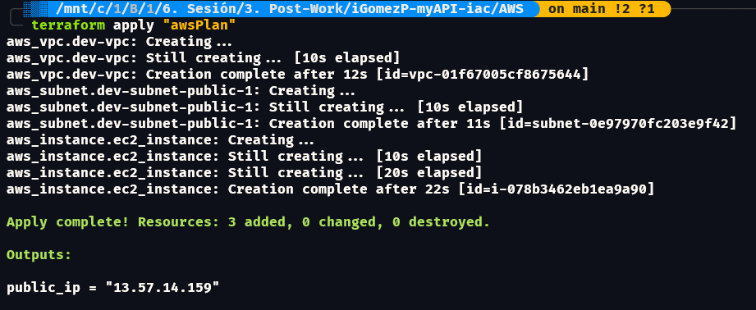

|  |  |  |
| --- | --- | --- |
| Requisito | Sí lo cumple | No lo cumple |
| a. Tener instalado Terraform en local | ✔️ |  |
| b. Identificar los comandos básicos para el despliegue y destrucción de ambientes | ✔️ |  |
| c. Crear nuestro primer despliegue | ✔️ |  |
| d. Crear un despliegue con un servidor en la nube de tu elección. | ✔️ |  |